Hybrid membranes based on ion-exchange membranes and zirconium compounds for electrodeionization process
Golubenko D.V.
student
Kurnakov Institute of General and Inorganic Chemisty, RAS, 31 Leninsky prospect,
Moscow 119991,Russia
E–mail: golubenko@igic.ras.ru
Electrodeionization is a water treatment technology that utilizes an electrode to ionize water molecules and separate dissolved ions (impurities) from water. The membrane permselectivity is the most important membrane parameter for electrodeionization process [1]. Unfortunately, due to the presence of mesopores [2], heterogeneous membranes cannot perfectly block the co-ion transport, which limits their applicability in this area.
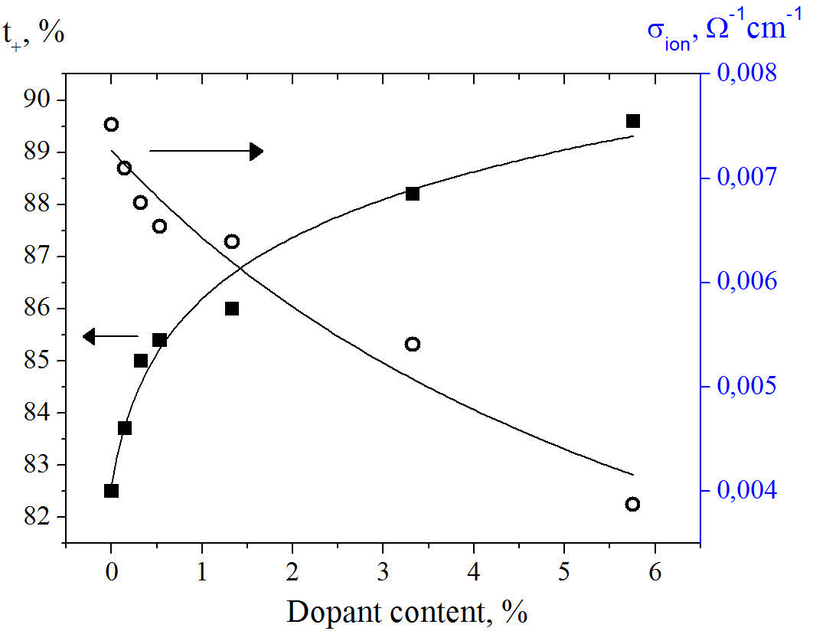
Fig.1. Selectivity (2M/0,1M NaCl) and ion conductivity (at 0,1M NaCl) of obtained hybrid membranes (t+(CMX©)=89,2%)
In this study we carried out the optimization of the electrochemical properties of heterogeneous membranes by in situ introduction of zirconium compounds, which significantly (up to the level of the membrane CMX© - one of the most selective ion exchange membrane) increase permselectivity and decrease the conductivity (Fig.1). Also the membrane with asymmetric distribution of the dopant was obtained, which allows to neutralize the worse ionic resistance of hybrid membranes while maintaining high permselectivity.

References
- Berezina N. P., Kononenko N. A., Dyomina, O. A, Gnusin N. P. Characterization of ion-exchange membrane materials: properties vs structure // Advances in Colloid and Interface Science. 2008, №139(1-2). p. 3–28.
- Křivčík J., Vladařová J., Hadrava J., Černín A., Brožová L. The effect of an organic ion-exchange resin on properties of heterogeneous ion-exchange membrane // Desalination and Water Treatment. 2010, №14(1-3). p. 179–184.
- Safronova E.Y., Volkov V.I., Yaroslavtsev A.B. Ion mobility and conductivity of hybrid ion-exchange membranes incorporating inorganic nanoparticles // Solid State Ionics. 2011, №188(1). p. 129–131.

