Conformational behavior of 1,1’-carbonylbipiperidine by quantum chemical calculations
Tran Dinh Phien
Postgraduate
Ivanovo State University of Chemistry and Technology
Department of Physical and Colloidal Chemistry, Russian Federation
Email: phientran@mail.ru
Piperidine and its derivatives are ubiquitous building blocks in the synthesis of organic compounds, including pharmaceuticals. To our knowledge, no information of chemical properties of 1,1’-carbonyldipiperidine (PCOP) is available in the literature.
In this study, the molecular structure and conformational properties of PCOP were studied by DFT-B3LYP and MP2 methods with 6-311G** and cc-pVTZ basis sets using Gaussian 09 and Firefly QC package version 8.0.0 (in case of MP2 for vibrational calculations). The both methods, B3LYP and MP2, predict that PCOP may be exist in form of three conformers AA, AE and EE, where we denote as A and E the conformations with the carbonyl group is in the axial and equatorial position at the nitrogen atom, respectively (see Figure). The structures of the conformers AA and EE are of the C₂ symmetry, and structure of AE – C₁ symmetry.

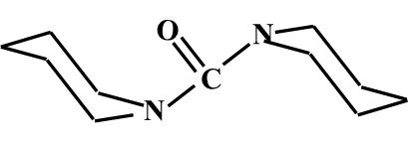 | 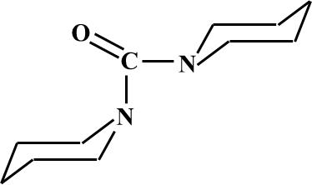 | 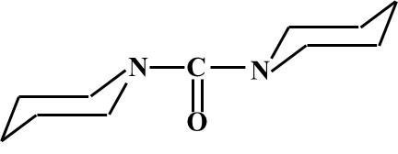
AA | AE | EE

The relative total electron energies ∆E calculated with 6-311G** basis set are 0.00, –0.08, –0.05 (DFT-B3LYP) and 0.00, 0.44, 0.98 kcal/mol (MP2) for the conformers AA, AE and EE, respectively. The ratio of the conformers was estimated on the base of the free Gibbs energies at 300 K as 23:34:43% (DFT-B3LYP) and 39:34:27% (MP2). At the same time, in case of more sophisticated basis set, cc-pVTZ, applied with DFT-B3LYP method leads to a strong change of the value ∆E: 0.00, –0.28 and –0.33 kcal/mol for conformers AA, AE and EE, respectively, while the value ∆G is 0.00, –0.34 and –0.54 kcal/mol. The latter corresponds to the conformers ratio AA:AE:EE=19:34:47%
According to the DFT-B3LYP/6-311G** calculation, energy barrier for nitrogen inversion process from AA to AE conformer is ∆E# =5.9 kcal/mol, while the value ∆E# for the nitrogen inversion process from EE to AE conformer is 4.0 kcal/mol.
The vibrational frequency of the carbonyl group is 1707, 1717, 1724 (DFT-B3LYP) and 1739, 1749, 1758 cm^{–1} (MP2) with 6-311G** basis set for conformers AA, AE and EE, respectively. This gives a chance to distinguish the conformers in IR spectrum.

The financial support of this work by the Ministry of Education and Science of the Russian Federation (Base Part, Project No. 1800) and the Russian Foundation for Basic Research (Grant 14-03-00923) is greatly acknowledged.

