Using Bloomberg ESG information in Company’s Sustainable Development analysis

Nedospasova D.D.

Student

Financial University under the Government of the Russian Federation

daria@nedospasova.com
The company’s Sustainable Development analysis is based on a comparison of real growth of its development and planned. The degree of compliance between them is measured using estimates of the stability and reliability of the company. [1] Indexes of sustainable development allow judging conditions in the economic, social or environmental variable.
Environmental, Social and Governance (ESG) as key factors of sustainable development. Companies use ESG as a risk assessment strategy incorporated into both their investment decision-making and risk management processes. As it is shown on Table 1 the company's ESG activities have the potential to positively impact its financial performance over the long term. [2]
Table 1. Impact of ESG activities on financial performance
Area of focus | Activity | Potential impact on financial performance
Environment | - Resource management and pollution prevention  - Reduced emissions and climate impact | - Avoid or minimize environmental liabilities  - Lower costs/increase profitability through energy and other efficiencies
Social | - Workplace  - Diversity  - Health and safety | - Improved productivity and morale  - Reduce turnover
Corporate Governance | - Executive compensation  - Board accountability  - Shareholder rights | - Align interests of shareowners and management  - Avoid “blow-ups”

Analytics and computational part. Using Bloomberg platform were analyzed three Russian oil companies: Bashneft, Rosneft and Lukoil to check whether they should be excluded from a sustainable portfolio. Using Bloomberg Service I checked the financial information, ESG Disclosure Scores, management profiles – to identify board interlocks, executive compensation-to evaluate whether the interests of shareholders and management appear to be alignment. I used such Bloomberg techniques, as:
1) Equity screening- to screen companies with the most attractive ESG disclosure. 2) Relative valuation – to compare a company with its peers on a wide variety of ESG factors. 3) Company filings – to access any company`s registration statements, periodic reports and other documents.
As result of the analysis it was found that Lukoil has the highest level of ESG indicators, as all aggregate ESG factors exceed others. Here it should be noticed that Lukoil began to use ESG analysis much earlier (since 2006 year) than two others companies. On the Pic 1 you can see the comparison of ESG indicators of these companies, where Red bar displays value of ESG Disclosure Score for Lukoil; Blue bar is for Rosneft and Green bar shows ESG Disclosure Score for Bashneft.
: 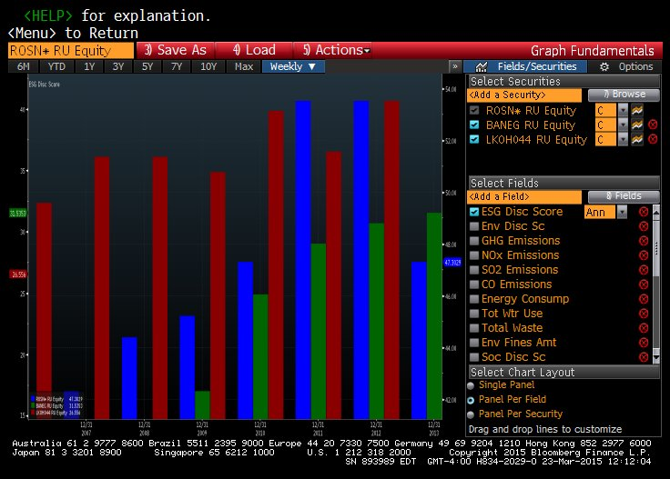
Pic. 1 Comparison of ESG indicators of Lukoil, Rosneft and Bashneft. [3]
Conclusion
As a result of research, it is possible to conclude, that all analyzed companies should be included in a sustainable portfolio but in different proportions: the largest part of shares should lie on Lukoil. We should not exclude Bashneft from the portfolio despite of low positions ESG indicators, because this company has positive dynamics of indicators and it makes effort to be sustainable. The study found that companies that incorporate ESG standards prove to be more conscientious, less risky and therefore more likely to succeed in the long run.
Bibliography
- Sustainable development Knowledge Platform 2015. [Electronic Source]. – Access mode: https://sustainabledevelopment.un.org/
- What is ESG? [Electronic Source]. – Access mode: http://www.esgmanagers.com/sustainable_investing/what_is_esg
- Bloomberg Service.

