Sigma model in 16-Spinor Nonlinear Field Model
Albaidhani Ahmed.K
PhD Student in Department Of Theoretical Physics, Peoples Friendship University Of Russia,Moscow.
ahmedkamilkh@mail.ru
1. Introduction
In the first Skyrme model (1954) [1] the topological charge Q has been interpreted as the baryon number B, The second model (Faddeev, 1972) [2] Hopf invariant Q_{H} interpreted as lepton number L and it played the role of the generator of the homotopy group, in Faddeev model. To unify Faddeev model (or Skyrme model) we introduce 16-spinor filed: , being 8-spinor and stands for Pauli matrices for each 8-spinor the following Brioschi identity form:
In this work we construct a Lagrangian density of our model, that is corresponding with Skyrme and Faddeev models:
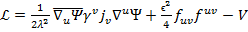
Where V Higgs potential, ) are constant parameters of the model, Newton gravitational constant, Kretschman invariant and interaction of spinor with the gravitational spinor field, Our aim in this work to simplified Lagrangian density by find lepton number and gravitation connection .

2. Lepton number:

Lepton number playing the role of the lepton charge in our model. We using the Whitehead integral to find the Hopf invariant:
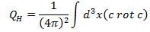
we can found from defiition of the vector , We can calculate the structure of vector which determining - manifold for lepton sector:
3. Spinor interaction:
Now let us introduce metric in geometric Toroidal coordinates, At small distance our metric has form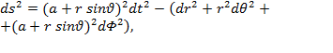the solution of Spinor interaction as a function of can be written as
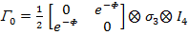
3. Conclusion:
Proposed Whitehead integral to find lepton number and found value of spinor interaction
References
[1] Skyrme T.H.R. A nonlinear field theory // Proc. Roy. Soc. London A 260. -1961 - P. 127.
[2] Faddeev L.D. Quantization of solitons. Preprint IAS print -7SQS70, 1975.
[3] Manton N. S. // Comm. Math. Phys. 111. -1987. - Pp. 469-478.

