A time course of the sum of glutamate and glutamine in response to a short visual stimulus
A. Yakovlev¹²³, M. Ublinskiy¹³, A. Manzhurtsev¹³
postgraduate, stuff, stuff
¹Clinical and Research Institute of Emergency Pediatric Surgery and Trauma, Moscow, Russia
²N.N.Semenov Federal research center of Chemical Physics Russian Academy of Sciences, Moscow, Russia
³N.M. Emanuel Institute of Biochemical Physics RAS, Moscow, Russia
Email: yakovlevalekcej@bk.ru
FMRI is one of the most widely used methods for the investigation of neural activity. Yet it still does not measure synaptic activity directly. BOLD-fMRI reflects the energy and blood-flow dependent processes that are not fully clear today. 1H-MRS is a non-invasive method of the absolute concentrations of neurochemicals measurement. Several studies have used the functional 1H-MRS with specific tasks. Until now there is only a few [1, 2, 3] studies of changes in neurochemical levels and brain activity measured with BOLD-fMRI and fMRS in one session. Here we provide the first measurement of glutamate+glutamine time course in response to a short visual stimulation. We have found the maximum of total Glx change caused by a short visual stimulus and have assessed the link between the Glx level and the BOLD-fMRI amplitude.
MRS data were acquired using a 3 T Phillips Achieva dStream MRI scanner (Philips Health Care, Eindhoven, Netherlands) and eight-channel SENSE head coil. Stimuli presentation and the attention response control were provided by the InVivo SensaVue system: the monitor and the system of mirrors. 28 healthy volunteers took part in the study (aged 23.6±2.2 years). Preliminary diagnostic study (3D T1w, T2w, FLAIR) was performed for each participant.
fMRI images were acquired using the EPI sequence with the following parameters: TR=3000 ms, number of dynamics =120, voxel sizes – 2,4х2,4х4 mm³, 30 slices. To acquire spectra we used PRESS sequence (TR=2000 ms, TE=35 ms, NSA=864 (12*72), voxel size – 20x30x20 mm³). Voxel was placed in the region of activated visual cortex. A similar paradigm of stimulation was used for both fMRS and fMRI: 4 Hz flickering checkerboard during 3 s and the black screen with a red fixation cross during 21 s (15 repeats for fMRI, and 72 repeats for fMRS).
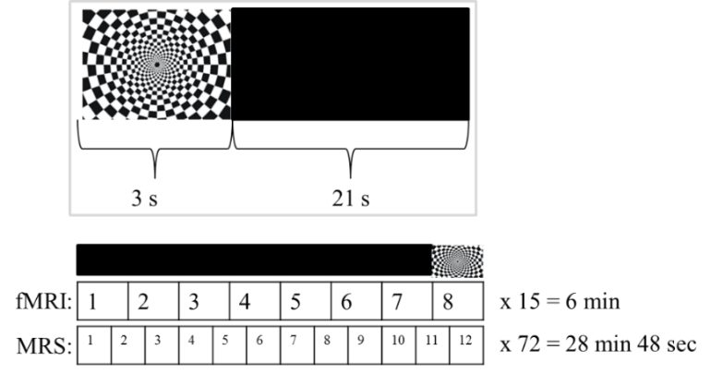
Figure 1. Visual stimulation paradigm: 3s of flickering checkerboard followed 21 s of a black screen. Acquisition of fMRI-BOLD signals and MRS spectra have different time patterns.
For the quality assessment of the obtained spectra, mean spectral frequency shift and width of tNAA and Cr peaks, as well as, Glx/Cr, CRLB of Glx and tNAA (from LCmodel) were obtained from each scan. If the averaged specrtum from one subject had three and more of these parameters differing from the mean by more than 1,5 standard deviations, this subject was excluded. Thus, six subjects were removed from the following processing. Each spectrum was preprocessed with FID-A [4]: frequency and phase aligning, dividing into the 12 series, each corresponding to a certain time point (i.e. for series at 3 seconds after stimulus onset the 13th, 25th, 37th and so on averages were picked; 1st average of each series were excluded due to unsteady state). Then “bad” averages were removed, the series were frequency and phase aligned, averaged and phased to 0 degrees. To exclude BOLD-related line narrowing effects on levels quantification, all time-point series were matched to the baseline series (23 s after stimulus, which is 1 s before stimulus onset). The averaged spectra of all series were processed in LCmodel [5] and Glx/Cr, tNAA/Cr ratio were acquired. To test the hypotheses of Glx variation in time, mean Glx/Cr values normalized to subject mean (across time) were analyzed in one-way ANOVA; if the ANOVA showed evidence of a significant effect, post hoc t-tests for dependent samples were used to identify which time points were different.
The fMRI data were processed using the SPM12 software package [6], an activation map was obtained in response to visual stimulation using GLM. Voxel mask was obtained in Matlab, and BOLD signal time course in this voxel was found. Correlation coefficient between the maximum of Glx/Cr and BOLD amplitude was obtained.
One-way ANOVA showed significant difference in twelve groups corresponding to each time point (p-val = 0,018). The point at 1 s after stimulus statistically significantly differs from the baseline point (-1 s, p-val = 0.002, see fig.2a) and from other points with p<0.01 (except for 3s). There is no correlation between Glx/Cr in its maximum and fMRI-BOLD amplitude (r=0.02).
*
a 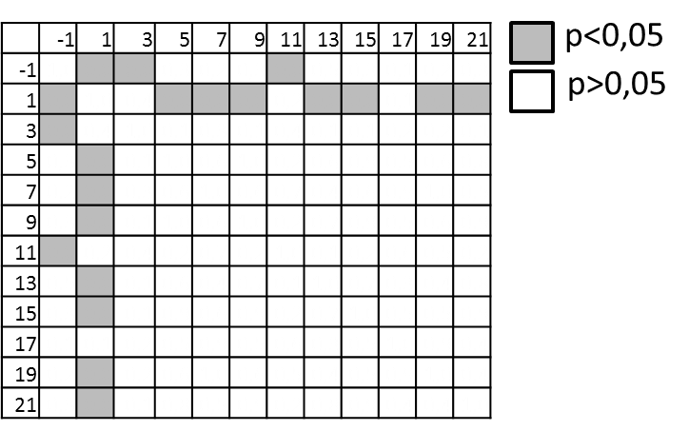b 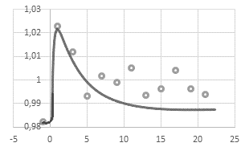
Figure 2. a) Matrix of statistical significance between Glx/Cr values in different times; b) A time course of Glx/Cr ratio normalized to the subject mean Glx/Cr (* - p=0,002).
We revealed the maximum of glutamate+glutamine change at 1 second after the short visual stimulus onset. This maximum is at least 3 seconds long. Since no statistically significantly changes between Glx/Cr values from 5 s to 21 s and -1 s, we believe that after the end of stimulus Glx quickly closes in to the baseline. The revealed 4% change is in good agreement with previous studies used prolonged stimuli [1, 3]. It is known that glutamate induces hemodynamic response [7], but the lack of the correlation between Glx and BOLD fMRI could mean that not only glutamate induces hemodynamic response or glutamate+glutamine and BOLD do not have linear relation.
- Ip I. B. et al. Combined fMRI-MRS acquires simultaneous glutamate and BOLD-fMRI signals in the human brain //Neuroimage. – 2017. – Т. 155. – С. 113-119.
- Apšvalka D. et al. Event-related dynamics of glutamate and BOLD effects measured using functional magnetic resonance spectroscopy (fMRS) at 3 T in a repetition suppression paradigm //Neuroimage. – 2015. – Т. 118. – С. 292-300.
- Bednařík P. et al. Neurochemical and BOLD responses during neuronal activation measured in the human visual cortex at 7 Tesla //Journal of Cerebral Blood Flow & Metabolism. – 2015. – Т. 35. – №. 4. – С. 601-610.
- https://github.com/CIC-methods/FID-A
- http://s-provencher.com/lcmodel.shtml
- https://www.fil.ion.ucl.ac.uk/spm/
- Attwell D. et al. Glial and neuronal control of brain blood flow //Nature. – 2010. – Т. 468. – №. 7321. – С. 232.

