Оценка положения оси и азимутального угла широкого атмосферного ливня по поперечному распределению черенковского света

Estimates of the extensive air shower core location and azimuthal angle using the lateral distribution of Cherenkov light

Латыпова В.С.¹
¹студент
Московский государственный университет имени М.В.Ломоносова,
физический факультет, Москва, Россия
E–mail: 2000vi0501g@mail.ru
SPHERE-2 experiment requires an algorithm to determine the position of extensive air shower (EAS) axis and the orientation of a Cherenkov light (CL) spot for the processing of the inclined EAS events. Using the CORSIKA code, samples of EAS artificial events with energy 10 PeV with zenith angles θ = 45° and 60° were simulated. An algorithm has been developed to estimate the position of the axis and azimuthal angle of the shower. The report presents the result of the algorithm application to the artificial events.

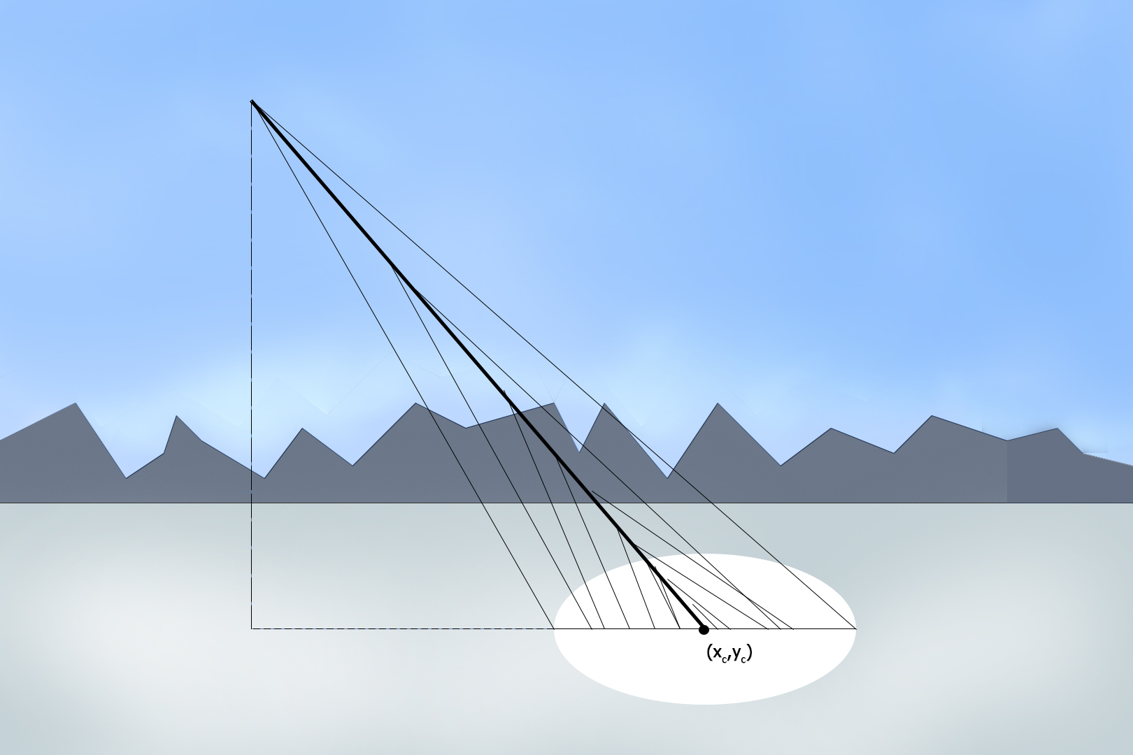

Наклонный ШАЛ

Литература
- R.A. Antonov, E.A. Bonvech, D.V. Chernov, T.A. Dzhatdoeva, V.I. Galkin, D.A. Podgrudkov,T.M. Roganova Spatial and temporal structure of EAS reflected Cherenkov light signal. // Astroparticle Physics 2019.

