2D Cd(II) coordination polymer assembled from sebacic acid and 1,2-bis(pyridin-4-ylethylidene)hydrazine ligands
Lozovan V.N.^{1,2}, Kravtsov V.Ch.³, Coropceanu E.B.^{1,2}, Fonari M.S.³
4rd year PhD student
¹Institute of Chemistry, Chisinau, Republic of Moldova
²Tiraspol State University, Chisinau, Republic of Moldova
³Institute of Applied Physics, Chisinau, Republic of Moldova
E–mail: lozovanvasile90@gmail.com
Infinitely extended metal–ligand networks with metal nodes and bridging organic ligands are called coordination polymers or metal–organic frameworks (MOFs). MOF's have attracted great attention lately due to the fact that they can be made porous, have large surface areas and tunable pore sizes and topologies, which leads to versatile architectures and promising applications such as ion exchange, adsorption, separation processes, drug delivery, for sensor technology, heterogeneous catalysis, luminescence, non-linear optics, magnetism etc. [1]. Polycarboxylic acids, as a crucial family of multidentate O-donor ligands, are the most popular choice of connecting ligands in the formation of coordination polymers with diverse multidimensional architectures. Simultaneous use of bis-monodentate N,N'-type ligands and dicarboxylate ligands can contribute to the formation of various architectures under the process of self-assembly. In this work we report a new 2D Cd(II) coordination polymer namely {[Cd(seb)(4-bpmhz)]·(H₂O)}_{n} derived from the semi-rigid Schiff-base N,N'-type ligand 1,2-bis(pyridin-4-ylethylidene)hydrazine (4-bpmhz) and sebacic acid (H₂seb) whose crystal structure were confirmed by single-crystal X-ray diffraction analysis (Figure 1).

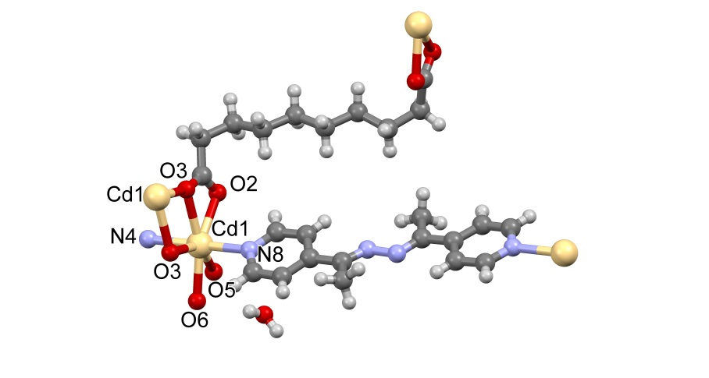 | 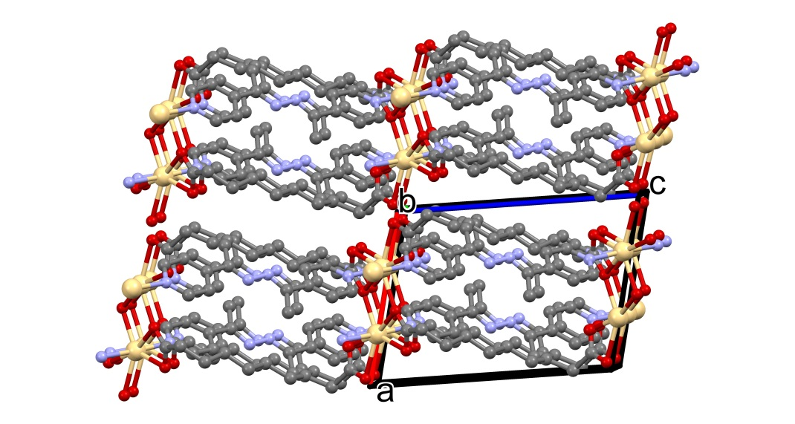
(a) | (b)
Figure 1. a) the fragment of polymeric network; b) packing of the 2D networks (hydrogen atoms are omitted for clarity)
Compound crystallizes in the triclinic P-1 space group: a = 10.0126(6), b = 11.3491(7), c = 12.8116(8) Å, α = 97.992(5), β = 97.620(5), γ = 114.365(6)°, V = 1283.84 Å³. The metal coordination nodes represent the binuclear clusters formed via chelate-bridging function of one of the seb residues. Each Cd(II) center adopts N₂O₅ pentagonal bipyramidal coordination geometry with two nitrogen donors from bipyridyl ligands, two oxygen atoms from chelating seb anion, and three oxygen atoms from other chelate-bridging seb anion. The nodes are mediated by bidentate bridging 4-bpmhz exhibiting two dimensional structure.
References
1. Janiak C., Vieth J. K. MOFs, MILs and more: concepts, properties and applications for porous coordination networks (PCNs) // New J. Chem. 2010. V. 34. I. 11. P. 2366-2388.

