Synthesis of Bragg mirror based on the 2D polymers
Butonova S. А., S. M. Morozova, A. V. Vinogradov
Master student, 1 year
ITMO University, Saint Petersburg, Russia
E–mail: butonova@scamt-itmo.ru
Bragg mirror is a structure with alternating layers with different refractive indexes [1].
These days, the most common methods for the synthesis of Bragg's mirrors are deposition from the liquid phase by spin- [2] dip-coatings [2,3] and sputter coating [3].
These layered structures are used as resonators in the manufacture of lasers [1]; anti-reflective coatings for various types of devices [1]; optical sensors [3], etc.
This project presents an innovative approach to the synthesis of Bragg's mirrors based on 2D polymers in the one-pot electrochemical deposition. The advantage of this method is the relatively low cost of the process, its high speed, and production scalability. A concept has been developed for this project, which is presented below.
Organometallic coordination polymers were selected because of a significantly lower refractive index compared to inorganic compounds, and compared to organic, more thermostable. Electrochemical deposition of the first layer of organometallic coordination polymer Cu₃(BTC)₂ (HKUST-1, BTC = benzene-1,3,5-tricarboxylate) was performed using a two-electrode electrochemical cell [4]. Consistent change from trimesic acid (H₃BTC) solution to aqueous copper sulfate solution led to the formation of layers with different refractive indexes: HKUST-1 layer with low refraction index and copper layer with high.
As a result of the research, the theoretical refractive indexes for each of the layers were calculated. In addition, the formation conditions of HKUST-1 and copper layers were studied, depending on the smoothness of the substrate, synthesis time, concentration and stirring. 4-layer Bragg mirror samples consisting of two layers of HKUST-1 and two layers of copper were obtained. The obtained layers were characterized using XRD, SEM, AFM methods.

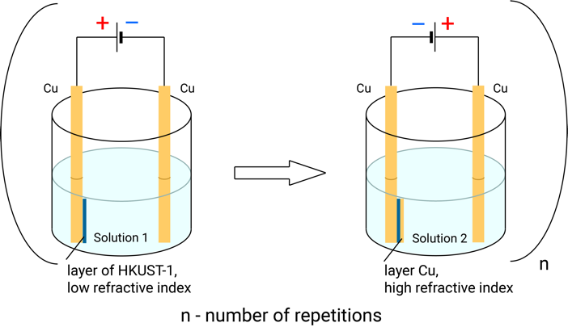
Figure 1. – Scheme of electrochemical synthesis of Bragg mirror. Solution 1: H₃BTC in EtOH and H₂O.
Solution 2: CuSO₄ in H₂O.

Acknowledgements
This work was supported by the Russian Science Foundation (Grant No. 16-19-10346).

References
1. Goldenberg, L. M., Lisinetskii, V. & Schrader, S. Fast and simple fabrication of organic Bragg mirrors - Application to plastic microchip lasers. Laser Phys. Lett. 10, (2013).
2. Calvo, M. E. et al. Photoconducting bragg mirrors based on TiO2 nanoparticle multilayers. Adv. Funct. Mater. 18, 2708–2715 (2008).
3. Dalstein, O. et al. Evaporation-Directed Crack-Patterning of Metal–Organic Framework Colloidal Films and Their Application as Photonic Sensors. Angew. Chemie - Int. Ed. 56, 14011–14015 (2017).
4. Campagnol, N. et al. High pressure, high temperature electrochemical synthesis of metal-organic frameworks: Films of MIL-100 (Fe) and HKUST-1 in different morphologies. J.Mater. Chem. A 1, 5827–5830 (2013).

