Inkjet printing of optical biosensors for detecting mental disorders
A.O. Goncharenko¹, S.M. Morozova¹, N.N. Scvortsova¹, A.V. Vinogradov¹.
Master student, 1 year
¹ITMO University, Saint Petersburg, Russia
E–mail: gocharenko@scamt-itmo.ru
Mental disorders have serious effects for the social sphere, human rights, and the economy.
The most important stage of psychiatric care for patients is the timeliness and correctness of the diagnosis. Therefore, creating additional objective laboratory or instrumental research methods is the actual issue. The proposed solution is to create a multi-marker test system of mental disorders.
According to published data, one of the biomarkers is glutamic acid [1].
The detection glutamic acid test system can be released by two variants of optical biosensors, which can be created with using by the inkjet printing. The differences due to two types of enzymes for detection such as glutamate dehydrogenase (GDH) and glutamate oxidase (GOD). In addition, the ranges of substance concentration were investigated as well as various options for the substrate for the biosensor. the optical response appeared as a result of the interaction of the GDH enzyme with the indicator layer (Fig. 1A) and GOD with the matrix (Fig. 1. B). As an indicator layer, metal ions salts Co²⁺, Ni²⁺ and Cu²⁺ were considered. The changes in optical response in the concentration range from 0.0125 to 0.2 Mol / l were studied. Also, various options for the substrate for the biosensor were considered and also was selected the matrix such as boehmite aluminum, xerogel titanium dioxide or without any matrix layer that was optimal for each types of enzymes.
In this study, the concept of a glutamic acid biosensor by inkjet printing was developed. It was found that, as an indicator in a biosensor with the GDH, the best results was achieved with Co²⁺ cation which was confirmed in addition to the visual change by deviations in RGB deviation.
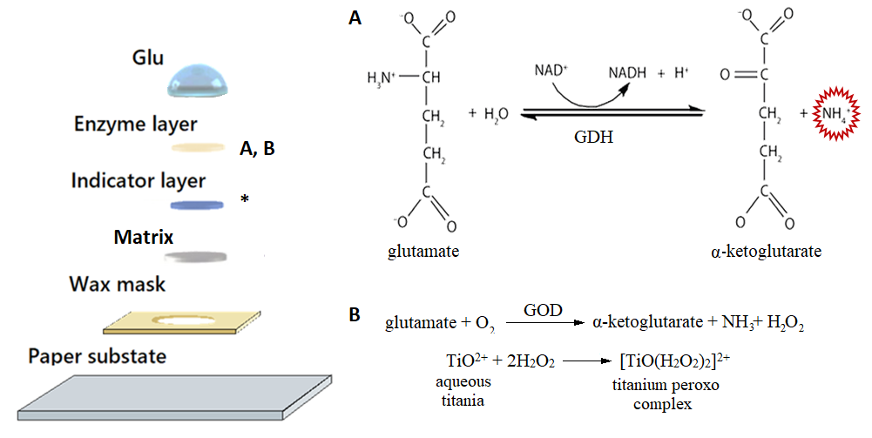
Figure 1. The general scheme of the biosensor in layers. If GDH (A) is used as the enzyme, then the indicator layer is preserved, and variations are possible for the matrix. If GOD (B) is used as an enzyme, then the matrix acts as an indicator layer.

Acknowledgements
This work was supported by the Russian Science Foundation (Grant No. 16-19-10346) and the Ministry of Education and Science of Russia (project No. 075-15-2019-1896).

References
1. Borisova T., An amperometric glutamate biosensor for monitoring glutamate release from brain nerve terminals and in blood plasma // Analytica Chimica Acta, 2018, vol. 1022.

