**Mechanical properties of single and polycrystalline solids from machine learning**

***Jalolov F.N., Podryabinkin E.V.,* *Oganov A.R., Kvashnin A.G.***

*Ph.D. student, 2 year of study*

*Skolkovo Institute of Science and Technology, Skolkovo Innovation Center, Moscow, Russia*

*E-mail:* [*faridun.jalolov@skoltech.ru*](mailto:ivanov@yandex.ru)

Calculations of elastic and mechanical characteristics of complex non-crystalline solids are challenging due to high computation cost of *ab initio* methods or low accuracy of empirical potentials. Modern methods of computational simulation allow one to predict the structure and physical properties of new materials mostly with single crystal structure and a certain stoichiometry.

Ideally obtained theoretical data can be used for further targeted synthesis of these materials, which should lead to a significant reduction in the time from search to development and implementation of a new material in practical applications. However, experimentally synthesized materials usually consist of polycrystallites or multiple phases. This leads to conclusion that experimentally measured properties of synthesized samples may significantly differ from calculated properties for single crystals. Thus, it is required to propose new methods towards description of physical properties of such complex systems (composites, multiphase systems, and polycrystalline materials) with high performance and accuracy.

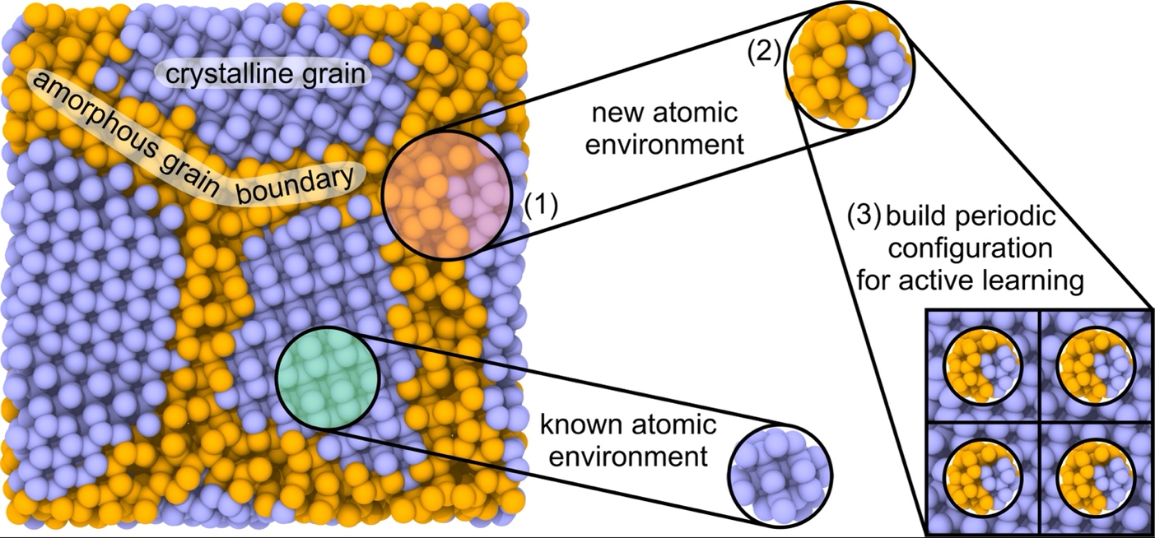We propose new computational technique toward efficient calculations of mechanical properties of single crystal and polycrystalline solids from atomistic point of view with high accuracy and reasonable computational cost by using machine learning interatomic potentials (MLIPs) based on moment tensor potentials (MTPs). MTPs were trained on a number of local atomic configurations for which forces, stresses and energies were calculated by using ab initio calculations. Developed automated approach allows one to perform calculations of elastic tensor, bulk and shear moduli of polycrystalline diamond with different grain sizes by using active learning of MTPs on local atomic environments in automatic. Test calculations of mechanical properties of more complex single crystals, namely SiC, WC, CrB4 were carried out to show the possibility of using this scheme to study materials with a mixed chemical bonding. This technique allows one to perform large scale calculations of mechanical properties of complex solids with high accuracy.

Fig. 1. Schematic illustration of learning on the local atomistic environments. The region highlighted by red (1) contains atoms, which cut from the structure (2), and used to build the periodic configurations (3) for further DFT energy, forces and stress calculations