**MOF-modified membrane for the extraction of lithium from oilfield brines**

**Doroshenko I.V. *1***, **Moshkova M.A. *1*, Filippova I.S. *1*, Poponina N.A. *1,*   
Gattabria C. *1*, Krivoshapkina E.F. *1***

*Student, 2 year of master’s degree*

*1ITMO university, ChemBio cluster, SCAMT institute, St. Petersburg, Russia*

*E-mail:* [*doroshenko@scamt-itmo.ru*](mailto:doroshenko@scamt-itmo.ru)

**Introduction.** Lithium, which is claimed to be the «Energy Metal in the 21st Century» [1], is in high demand due to the rising use of electric vehicles and high-tech electronics powered by lithium-ion batteries. With global demand increasing rapidly, concerns about potential scarcity are growing. To mitigate this issue, newly-introduced solutions are essential. Innovative direct lithium extraction technologies offer significant potential to expand lithium supplies, particularly from water sources, including lithium-rich wastewater from oil and gas condensate operations.

**Body part of the report summary.** Using a composite membrane as an extractor module is a beneficial method for achieving high-purity lithium from wastewaters’ concentrate. The proposed membrane is based on polyamide substrate (PA) that has been modified multiple times with a metal-organic framework zeolitic imidazolate framework-8 (ZIF-8). PA is an economical supporting material that maintains strong stability during the metal-extraction process. ZIF-8 was chosen for ion-selective separation because of its consistent porosity, appropriate size attributes, and large surface area, which make this framework especially effective for lithium recovery processes [3].

A hydrothermal modification was used to introduce ZIF-8 onto the membrane surface. This modification process was performed multiple times to ensure a uniform ZIF-8 layer across the entire membrane, as it is crucial towards achieving the desired selectivity. Figure 1 represents the scheme of the synthesis.

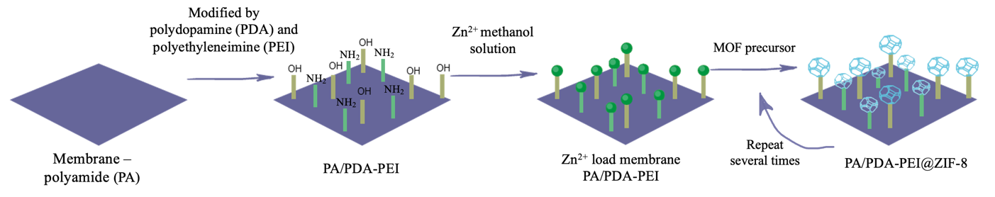

Fig. 1. The membrane modification process

After analyzing the surface with the help of Fourier transform infrared spectroscopy, Scanning electron microscopy, and Energy-dispersive X-ray spectroscopy we confirmed the successful synthesis and revealed the presence of ZIF-8 layer on the surface of membranes. The consequent stage of the research included the identification of the most promising number of ZIF-8 layers onto the membrane by the means of chronoamperometry and linear sweep voltammetry tests in a model of an electrochemical cell. These tests are crucial in order to identify a membrane with the most uniform and intact metal-organic framework coating.

**Conclusions.** A thorough evaluation of lithium extraction techniques was performed, and the results of this evaluation led towards choosing the ion-selective membrane as the most promising technology for extracting lithium from oilfield waters. Subsequently, the most viable practical modifications of the membrane were synthesized and studied.

*The work was supported by state assignment No. FSER-2025-0016 within the framework of the national project «Science and Universities».*

**References**

1. Garcia L. V. *et al.,* “Lithium in a Sustainable Circular Economy: A Comprehensive Review,” Processes, vol. 11, no. 2, p. 418, Jan. 2023.
2. I. Energy Agency, The Role of Critical World Energy Outlook Special Report Minerals in Clean Energy Transitions.
3. Yu H. *et al.*, “Selective lithium extraction from diluted binary solutions using   
   MOF-based membrane capacitive deionization,” *Desalination*, vol. 556, p. 116569, Jun. 2023.