**Synthesis of a combined pharmaceutical substance potentiating the action of the iodine-antibiotic system**

***Shepilov D.A., Sagyntayeva T.K., Anarova A.S., Iskakbayeva Zh.A.***

*Student, 1st year Master’s degree*

*JSC «Scientific center for anti-infectious drugs», Laboratory of new materials and substances, Almaty, Kazakhstan*

*E-mail: shepilov2002@gmail.com*

Antibiotic resistance is one of the leading causes of mortality associated with infections caused by resistant microorganisms. Antibiotic potentiators represent a promising solution by accelerating the development of new medications through the enhancement of existing drug efficacy. The compounds KS-246 and KS-248, obtained through the following synthesis with sodium sulfadimidine and gentamicin sulfate, respectively, were subsequently investigated as potentiators.

Iodine and its salts were selected for this study due to the intrinsic susceptibility of infectious pathogens to iodine-containing compounds and the absence of a tendency for acquired resistance development [1]. Gentamicin sulfate was selected for its ability to inhibit bacterial protein synthesis by binding to the 30S ribosomal subunit and sodium sulfadimidine for its inhibition of folic acid synthesis, disrupting bacterial metabolism and replication.

Synthesis design included quantum chemical calculations using the DFT/B3PW91/6-31G** method to assess the binding energy [2]. The synthesis was performed by combining antibiotic solutions with an iodide-iodine mixture, followed by crystallization. Controlled reaction conditions ensured homogeneous component distribution and stability of the obtained product. Crystallization was carried out in a desiccator with calcium chloride to ensure gradual solvent evaporation and crystal formation. The synthesis resulted in stable, water-soluble compounds with melting points of 56-57 ±0.71 °C and 60-61 ±0.58 °C, respectively.

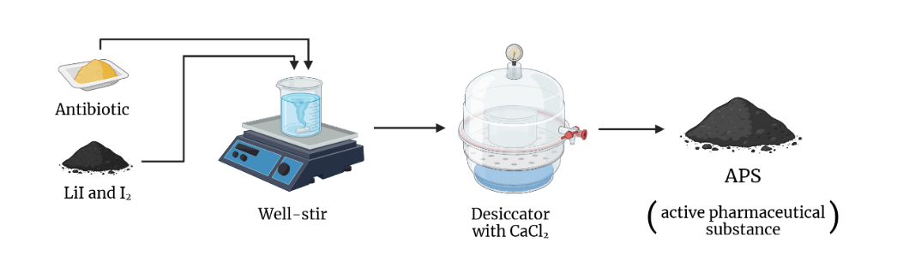

Fig. 1. Principal scheme of APS synthesis

The impact of the new drug on antibiotic resistance of pathogens was assessed by its effect on biofilm formation and the disruption of established biofilms by SBF (specific biofilm formation) index [3]. In the selected test cultures, SBF was reduced to 65% for E. coli, 45% for S. aureus, and 17% for Pseudomonas aeruginosa, relative to the control group without a potentiator.

*This research has been funded by the Committee of Science of the Ministry of Science and Higher Education of the Republic of Kazakhstan (Grant No. BR24992760).*

**References**

1. Красильников А.П. Справочник по антисептике: справочное издание. Минск : Выcш. шк., 1995. 367 С.

2. Ilin A., Kerimzhanova B., Yuldasheva G. Action Mechanism of Molecular Iodine Complex with Bioorganic Ligands, Magnesium and Lithium Halogenides on Human Tuberculosis Strain with Multiple Drug Resistance // J. Microb. Biochem. Technol. 2017. Vol. 9(6). P. 293-300.

3. Oduwole K.O., Glynn A.A., Molony D.C., Murray D., Rowe S., Holland L.M., McCormack D.J., O'Gara J.P. Anti-biofilm activity of sub-inhibitory povidone-iodine concentrations against Staphylococcus epidermidis and Staphylococcus aureus // J. Orthop. Res. 2010. Vol. 28. P. 1252-1256.