**“Phenomenological views on 'Han style' factors in stone carvings on the tomb slabs of Sima Jinlong's tomb”.**

With the spread of Buddhism in eastern China, Buddhist art encountered and merged with local art in China and was subsequently localized. The period of the Wei, Jin, Northern and Southern dynasties was a crucial time for the localization of Buddhism in China, but the north of the country was largely ruled by ethnic minorities and nomadic regimes until the Northern Wei dynasty was unified by Emperor Taiwu, when the Xianbei people established their long-term dominance over Northern China. During the reigns of Emperors Wencheng, Xianwen, and Xiaowen, Buddhism in the Northern Wei Dynasty flourished and was accompanied by Sinicization reforms, which led to the evolution of Buddhist artistic images into the “Han style”. According to Husserl's phenomenological theory (Edmund Gustav Albrecht Husserl), an image is the embodiment of the consciousness of the image, so in the process of Sinicization of Buddhist art, the change of its artistic image is not only influenced by the government's Sinicization reforms that lead to change and development.Therefore, introducing phenomenological theories such as Husserl's theory in revealing the Sinicization process of Buddhism is of great significance in understanding the “Chinese style of powdered text” in the fusion of its arts.

**Methods**

After the Northern Wei Dynasty unified the north, Xiangbei culture began to return to the Han system through the “Hanization reform” in the Taihe period, which manifested itself in the trend of “Hanization” of living culture Religion was the result of the “Han style” and the mixing of different cultural and artistic forms. Sima Jinlong of the Han family of the Northern Wei Dynasty Han family of the Southern Capitulation, Han art in his tomb is obvious, but in this article, “Han” art to analyze it can be divided into “broad” and “narrow”. The broad concept of “Han system” is the political and cultural concept developed by the Han people who lived in the traditional Han territory and spread to different regions. The Han system in a narrower sense is a cultural concept developed during the Han Dynasty. Based on the broad concept of “Han system” and the phenomenological theories of Husserl and other scholars, this paper explores the origins of the fusion of Buddhist elements and “Han style” in the image of Palmette born in a lotus flower, accompanied by the palm prints on the stone carvings on Sima Jinlong's coffin bed, in order to incorporate Buddhist elements into the “Han style” art system. Buddhist elements in the “Han style” art system.

**Conclusion**

The coffin bed pattern of Sima Jinlong's tomb (Fig. 1) with the relief of the square base of the stone pillar shows relief carvings in the form of Palmette, cloud motifs and kabuki children. Two of them have a three-dimensional kabuki child carved in each corner playing drums (drum, belt drums), shauma and pipa, while the ralmetta is in the form of an intricate two-sided continuity, with an undulating twist of rattan, with a strong emphasis on line carving. This type of expression can be seen in the frescoes of tombs of the Western Han Dynasty Kakien Han Dynasty in the state of clouds enveloping branches, Sima Jinlong as the aristocrats of the Eastern Jin Dynasty, the shape of their tombs in the Xianbei culture area in China deeper. Among them are Palmette branches wrapped around the kabuki children, the image of the kabuki children is similar to the image of the children born in the lotus flower of the lotus flower of the five Yungan caves (Fig. 2) anhao and the fifth cave of Tiantishan Grottoes, the limbs are strong and the body has a floating belt, so that at the latest at this time, the transformation of the image of the cloud pattern in the system of Immortals and Ruyi Beasts into the image of Palmette was completed in the Pincheng area. The image of immortal beasts was also transformed from sacred beasts in Chinese canonical texts into the lotus flower-born children that adorned Buddhist grottoes. The combination of Palmette and lotus flower-born children and the inclusion of the image of lotus flower-born children in the image of “auspicious symbols” may have been the first step in the Chineseization of Buddhism in the middle of the Northern Wei Dynasty. It is not found in Buddhist art of Central Asia.The combination of Palmette and the phenomenon of “mythical beast” and “child” may indicate the fusion of Buddhist and immortal concepts of life and death, from “mythical beast” to “child born in a lotus flower”. The transformation from “auspicious beast” to “lotus child” shows that the Buddhist concept of reincarnation is gradually displacing the traditional concept of immortality

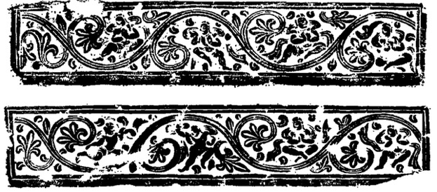

Figure 1. Stone carving on the coffin bed in Sima Jinlong's tomb, photo provided by: “Sima Jinlong's Tomb of Shijiazhai, Northern Wei Dynasty, Datong, Shanxi”.

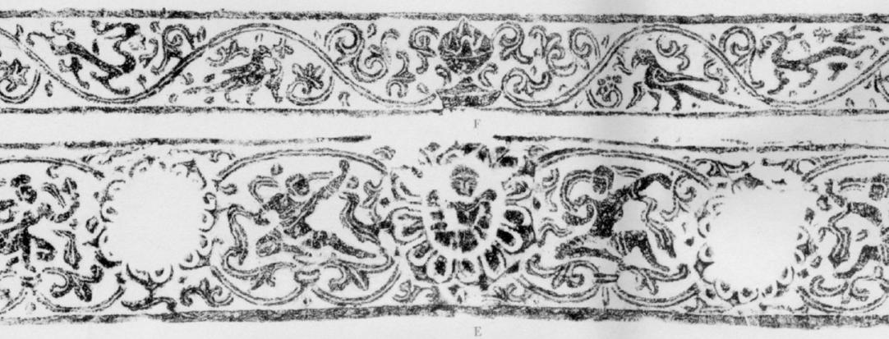

Figure 2: The lintel of the back room of Yungang Grottoes Cave 10, photo provided by: Yungang Grottoes.

**Keywords**

Sima Jinlong's tomb, Yungang Grottoes, Sinicization reforms, Sinicization of Buddhist art

**Summary of the main text**

1. Iconographic analysis of stone carvings on the coffin bed of Sima Jinlong's tomb

2. Homogenization of iconographic consciousness between the image of Nendoroid and the Transfiguration Child

3. The image of the Child of Transfiguration in the Rong Sui system

**References**

1. Yu Weichao, “Analysis of the burial forms of vassal kings and marquis under the Han Dynasty and discussion of the three stages of the Zhou, Han and Jin systems”, Proceedings of the Second Annual Meeting of the Chinese Archaeological Society, Cultural Relics Publishing House, 1980.

2. Li Meitian, “Ascending to immortality or Buddha status: changes in the concept of life and death reflected in burial art between the Han and Tang dynasties,” Lecture Notes of the Department of History, Fudan University, 2023.05.19.

3. ni Liangkang, “Phenomenology of Image Consciousness”, Journal of Nanjing University - Philosophy - Humanities and Social Sciences, vol. 38, 2001, 34.

4. Ni Liangkang, “On the phenomenological analysis of imagination and its various categories of consciousness,” Phenomenological Studies. № 2, 2021, 88

5. (USA) Bao Huashi, translated by Wang Jinfeng, “Image and Society,” Zhejiang People's Publishing House, 2023, 6, 22-24