**The Impact of Primordial Black Holes (PBHs) on the Cosmic Microwave Background (CMB) Angular Power Spectrum**

***Bingbing Hu***

***Department of Physics, Nanchang University***

***Nanchang, China***

**Email: hbb28919_study@outlook.com**

Primordial black holes (PBHs) are a class of black holes that may have formed in the early universe. In recent years, they have attracted considerable attention due to their potential roles in dark matter, cosmic structure evolution, and gravitational wave detections.

this study, we utilize BlackHawk to compute the radiation flux from PBH evaporation [1] and employ CLASS to evaluate the impact of PBHs on the CMB angular power spectrum. By fitting Planck 2018 CMB data with Python, we investigate how PBHs of different masses and abundances modify the CMB. PBHs can influence the CMB through Hawking radiation, gravitational lensing, and reionization processes [2]. In particular, the high-energy photons emitted via Hawking radiation can alter the CMB spectrum, increase optical depth, and modify the CMB angular power spectrum. Current observations impose stringent constraints on PBH abundance, yet PBHs may still induce observable effects within specific mass ranges [3].

First, we use BlackHawk to compute the PBH evaporation photon spectrum, setting the PBH mass range to ${10}^{13}-{10}^{16}$ g and calculating the high-energy photon flux for different PBH masses. We extract the PBH photon spectrum contributing to the CMB and determine the energy injection rate:

$$\frac{dE}{dV dt} = f_{\text{PBH}} \int{\frac{dN}{dE} E dE}$$

where $\frac{dE}{dVdt}$ represents the energy injection rate per unit volume per unit time. The high-energy photon injection rate varies with PBH mass, with lighter PBHs (${10}^{14}g$) having the most significant impact on the CMB.

Based on this, we further examine the PBH-induced modifications to the CMB angular power spectrum ($C_{l}$):

$$C_{l}^{\text{PBH}}=C_{l}^{Λ\text{CDM}}+ΔC_{l}$$

where $ΔC_{l}$ represents the PBH-induced corrections to the CMB angular power spectrum. The method involves modifying the CLASS `input` file to incorporate PBH effects by inputting the PBH energy injection rate. By comparing the CMB signals before and after including PBH effects, we observe that high-energy photons increase the optical depth $τ$, leading to modifications in the E-mode polarization power spectrum $C_{l}^{EE}$. Additionally, PBH contributions introduce observable deviations in the CMB temperature fluctuations $C_{l}^{TT}$ at small scales ($l>1000$).

We fit Planck 2018 CMB data using Python to assess the observational constraints on PBHs. When the PBH abundance is low ($f_{\text{PBH}}<{10}^{-3}$), the PBH contribution remains within Planck’s observational uncertainties. However, for higher PBH abundances, the deviations may become inconsistent with observational data.

Our results indicate that low-mass PBHs may induce observable effects on the CMB angular power spectrum, whereas high-mass PBHs have a lesser impact. Future CMB observations, such as CMB-S4 and LiteBIRD, are expected to further tighten constraints on PBH contributions.

**Keywords:** Primordial Black Holes (PBH), Cosmic Microwave Background (CMB), Hawking Radiation, CLASS, Planck 2018.

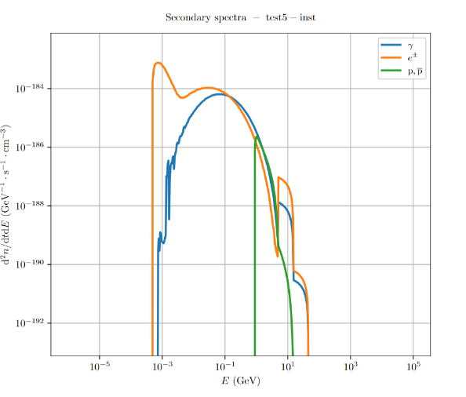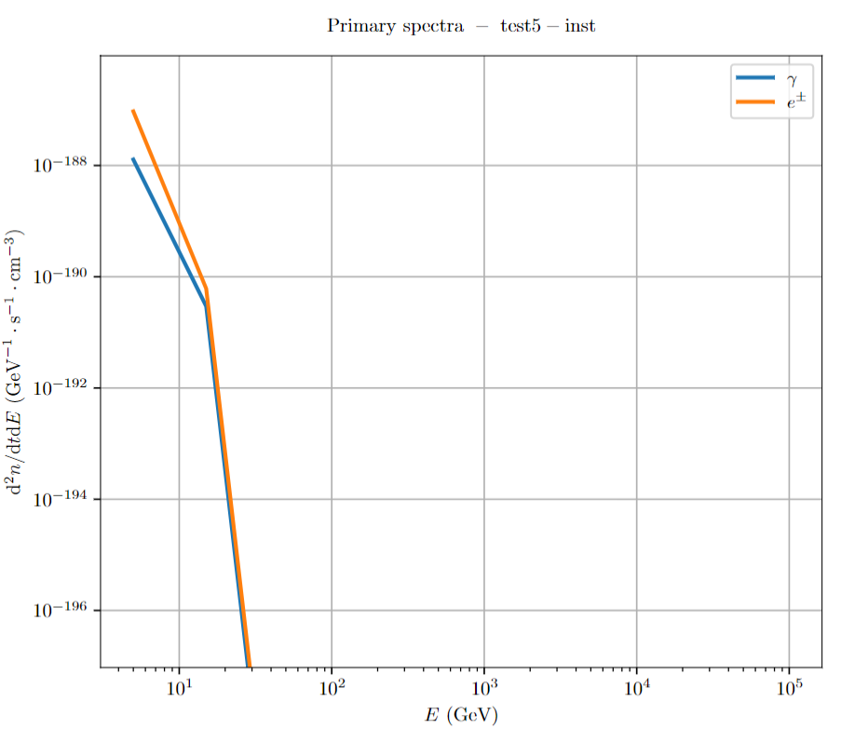

Figure 1: Primary instantaneous spectrum

Figure2: Secondary instantaneous spectrum

**References**

1. Arbey, A., Auffinger, J., & Silk, J. (2020). "BlackHawk: A public code for calculating the Hawking radiation spectra of any black hole distribution." European Physical Journal C, 80(3), 167.

2. Carr B. J., Hawking S. W. (1974). "Black holes in the early universe." Monthly Notices of the Royal Astronomical Society, 168(2), 399-415.

3. LIGO Scientific Collaboration and Virgo Collaboration (2019). "Search for Subsolar-Mass Ultracompact Binaries in Advanced LIGO's Second Observing Run." Physical Review Letters, 123(16), 161102.