Low Phase Noise Microwave Oscillator Based on Platicon Comb in Integrated Microresonator
Li Chengcong ^{1,2*}, Shitikov A.E. ¹
Li Chengcong(PhD student),Shitikov A.E.(Doctor)
1-Russian Quantum Center, Moscow, 143026, Russia
2-Faculty of Physics, M.V. Lomonosov Moscow State University, 119991 Moscow, Russia
E–mail: chengcong.li@rqc.ru
With the development of integrated photonic, optical Kerr microcombs in silicon nitride microresonators have become an invincible tool for cutting-edge technologies. Optical Kerr frequency combs are among the most valuable phenomena leveraging high Q-factors of on-chip microresonators. Such combs are called microcombs. They have found their applications in science and technology and have brilliant potential in the future ^{[1]}. Microcomb is a simple and effective way to generate a microwave signal, with high stability and purity of the frequency ^{[2-5]}. Self-injection locking technique allows to miniaturize the setup up to several cm³. Self-injection locking of a laser-without-isolator frequency to a frequency of a high-Q microresonator is a straightforward and robust way of the laser frequency stabilization. The Rayleigh scattering provides all-optical frequency selective feedback. Self-injection locked laser may achieve a sub-Hz instantaneous linewidth. Based on self-injection locking, a high-Q Si₃N₄ integrated microresonator we demonstrate an exceptionally stable platicon microcomb for generating a pure and stable microwave signal.

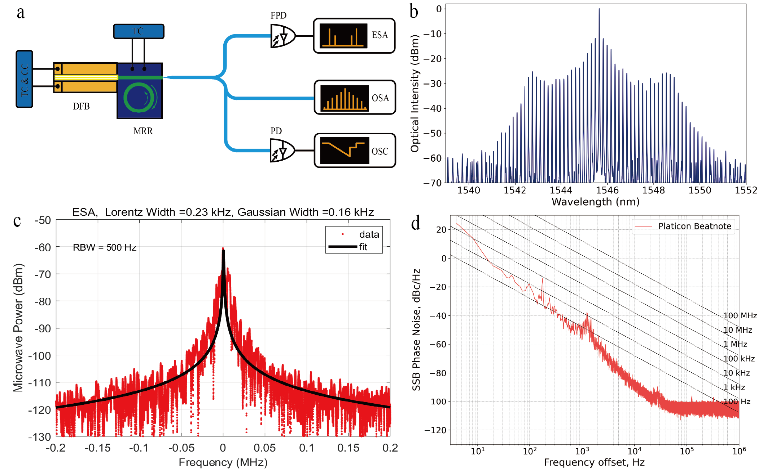
Fig. 1. a) The sketch of experiment: TC and CC – temperature and current controllers; DFB -laser diode; MRR – Si₃N₄ microresonator; TC – temperature controller; PD and FPD – slow and fast photo detectors; OSC – oscilloscope; ESA – electrical spectrum analyzer; OSA – optical spectrum analyzer. b) Optical spectrum of the platicon. c) Lorentz linewidth fitting of microwave signal. d) The phase noise spectral density of the microwave signal. It reaches -85 dBc/Hz@10 kHz.

The sketch of experimental setup is presented in Fig. 1a. A distributed feedback (DFB) laser is butt-coupled to photonic chip. The output optical signal is collected by a lensed fiber and signal is divided into three parts. One part of the output connected to optical spectrum analyzer (OSA). The second part of the signal is connected to a fast photodetector and an electrical spectrum analyzer (ESA) and the last part of the signal is sent to a photodetector and an oscilloscope (OSC). The temperature of the DFB laser and photonic chip is stabilized. We slowly scan the DFB laser frequency changing its operating current across the vicinity of the microresonator’s eigenfrequency. When the microresonator mode is excited due to the roughness of microresonator surface, Rayleigh scattering occurs and part of the light is reflected to the DFB laser, resulting in self-injection locking. We also use a piezo controller to slowly change the locking phase controlling the distance between DFB laser and photonic chip.
The thickness of micro ring is 300 nm, the width is 3 um, free spectral range (FSR) is about 21.36 GHz, the group velocity dispersion (GVD) is −0.36 MHz which corresponds to normal GVD regime. The Q factor of micro ring is over 10^7. For this microresonator chip, the intrinsic decay rate is 11 MHz (), coupling decay rate is 8 MHz () and backward-wave coupling rate is 9 MHz () at the wavelength is 1545.5265 nm. DFB laser at about 1545 nm and the output power over 100 mW is used as a pump.
Conducting the experiment, we employed the forward detuning current of DFB laser (from 410 mA to 435 mA) and achieved an exceptionally stable microcomb spectrum when the current was tuned to approximately 420 mA. The spectrum corresponds to platicon, dark soliton at the normal GVD, it is presented in Fig. 1b. When the platicon passed to the fast photodetector, we obtained microwave signal with impressively narrow linewidth at 21.36 GHz. By fitting the microwave signal with the Voigt profile, the Lorentzian part of the approximation is 0.23 kHz, and the resolution bandwidth (RBW) is 500 Hz, the beatnote is presented in Fig. 1c. Subsequently, we conducted phase noise measurements of this microwave signal and achieved a result lower than -85 dBc/Hz at 10 kHz, as shown in Fig. 1d. For comparison, in the work ^{[4]} used normal dispersion silicon nitride microresonators, reported a phase noise level of -65 dBc/Hz at 10 kHz in 2022^{[4]}. Our results, therefore, represent a significant improvement over previous work.
To conclude, we used integrated high-Q silicon nitride microresonators and self-injection locking technique to obtain the microwave source at 21.36 GHz with phase noise as low as -85 dBc/Hz at 10⁴ Hz.

The work was supported by Rosatom in the framework of the Roadmap for Quantum computing (Contract No. 868-1.3-15/15-2021).

Refercenes
- Marpaung, Integrated microwave photonics, Nature Photon 13, 80–90 (2019).
- N. M. Kondratiev, et al. Self-injection locking of a laser diode to a high-Q WGM microresonator, Opt. Express 25, 28167-28178 (2017).
- N. M. Kondratiev, et al. Recent advances in laser self-injection locking to high-Q microresonators, Front. Phys. 18, 21305 (2023).
- Lihachev, et al. Platicon microcomb generation using laser self-injection locking, Nat Commun 13, 1771 (2022).
- W Sun, et al. arXiv:2403.02828, 2024.

