Reviving fissured solar cells through self-healing
Linda Boudjemila

The Bonch-Bruevich Saint Petersburg State University of Telecommunications
St. Petersburg, Russia
lariessai21@gmail.com

Mixed-halide perovskites have emerged as outstanding light absorbers that enable the fabrication of efficient solar cells; however, their instability hinders the commercialization of such systems. A strategy for inter-grain cross-linking is proposed, utilizing a macromolecular intermediate phase created with a polymeric Lewis base, to facilitate the straightforward production of highly efficient and stable perovskite solar cells. The integration of inter-grain cross-linking polymers into perovskite solar cell (PSC), particularly cesium lead iodide CsPbI₃ particularly cesium lead bromine CsPbBr₃ represents a significant advancement in the quest for stable and efficient photovoltaic devices. The choice of CsPbI₃ and CsPbBr₃ is based on their different band gap 1.73 eV and 2.3 eV respectively. Perovskite materials having the crystal structure ABX₃ are a notable semiconductor known for its excellent light absorption, tunable bandgap, and high carrier mobility, making it a prime candidate for next-generation solar cells. However, the inherent instability of CsPbI₃ or CsPbBr₃ under environmental stressors such as moisture and heat has hindered its practical application. By incorporating self-healing polymers into ABX₃ matrix, researchers aim to enhance the material's durability and longevity while retaining its impressive optoelectronic properties. Self-healing polymers are designed to autonomously repair damage through dynamic chemical bonds that can reform after being disrupted. This ability can be attributed to various physical phenomena, including reversible covalent bonds and ionic interactions. Recent improvements achieved via compositional and interfacial engineering which have resulted in a rapid increase in the power conversion efficiency (PCE) [1]. A during applied to CsPbI₃ or CsPbBr₃, these polymers can effectively mitigate the adverse effects of micro-cracking of silicon base substrate under environmental degradation that typically plague perovskite materials. The self-healing mechanism operates at the molecular level, where the polymer chains reconfigure in response to damage, restoring structural integrity and maintaining efficient charge transport pathways.
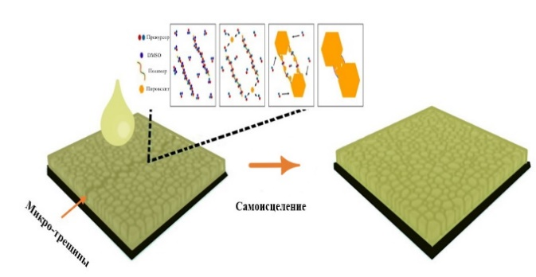
The studied solar cells are solar cells of third generation. It’s principally coated by different layers of different materials. The first sample is made of double junction crystalline silicon (c-Si) with a thickness of 0.18 [2] Among the various available coating techniques, spin coating technique was used for depositing different layers of the PSC. 200 µl of PEDOT: PSS solution was used to deposit the first layer over the silicon substrate by spin coating technique. The coating speed was 1500 rpm for a period of 60 seconds. This was followed by thermal annealing at a temperature of 373 K for 10 minutes. After the layer drying, using a one-step approach, the polymeric Lewis base poly (propylene carbonate) (PPC, [C₄H₆O₃]n) [2] was incorporated into the active layer CsPbI₃ and CsPbBr₃ as depicted in Fig. 1. The substrate was coated with the active layer mixture CsPbI₃/self-healing Polymer PPC and CsPbI₃/self-healing Polymer PPC. The spinning parameters for the active layer solution was 800 rpm over a duration of 60 seconds. The polymer addition aids in smoother deposition due to the increased viscosity, which is reflected in the film quality too.
- Illustration of cross-linker aided crystallization on PSC.
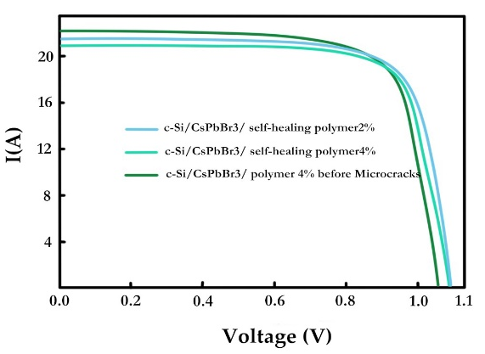
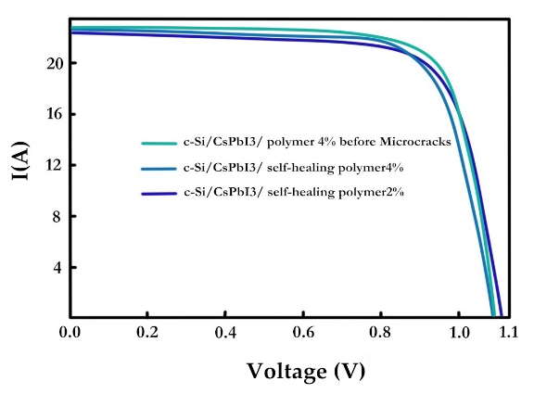
Precursors for metal halide perovskites, including Pb (II) halides (such as PbI₂, PbBr₂, or PbCl2) and organic halides (like CH₃NH₃I), are recognized as Lewis acids. When a Lewis acid reacts with a Lewis base, it can result in either a redox reaction or the formation of an adduct [3] The latter consists of the acid and base connected by a dative bond, which involves shared electrons originating from the Lewis base. Long-chain polymers can be immobilized after the perovskite crystallizes, whereas small molecule additives exhibit significant diffusion and drift mobility within the perovskite film during operation. The I-V characteristics of the prepared devices under AM 1.5 illumination with an intensity of 100 mW/cm2 are shown in Fig. 2.
(a)
(b)
Fig.2. Representative EQE spectra and integrated current density of devices fabricated at the champion conditions.
The I-V curves were recorded before and after the self-healing treatment to assess the impact on device performance. Prior to self-healing, the PSC c-Si/CsPbI₃ microcracked exhibited a short-circuit current (Jsc) of 22.5 mA/cm², an open-circuit voltage (Voc) of 1.05 V, and a fill factor (FF) of 75%, resulting in an initial power conversion efficiency (PCE) of 21%. Following the self-healing process, the PSC c-Si/CsPbI₃/PPC4 %, the I-V characteristics demonstrated significant improvement. The Jsc increased to 24.8 mA/cm², while Voc rose to 1.12 V, with FF improving to 78%. Consequently, the PCE reached 23.8 %, indicating an enhancement of approximately 2.8 % absolute efficiency. Introducing PPC4% leads to the most pronounced modifications on FF that increases from 0.443 (for PSC with microcracks) to 0.546 (with PSC PPC4 % and PPC2 %). The increased FF indicates an increase in the ability to extract holes between perovskite layer and carbon electrode in hole-conductor-free PSCs and the speed at which electrons and holes are extracted tends to be more balanced. The observed improvements can be attributed to the repair of defects and grain boundaries within the perovskite layer, which facilitated better charge transport and reduced recombination losses. These findings underscore the potential of self-healing strategies in enhancing the performance and longevity of perovskite solar cells in practical applications.
References
[1] N. J. Jeon, and et. al. “Compositional engineering of perovskite materials for high performance solar cells,” Nature, vol. 517, pp. 476–480. May 2015.
[2] T. H. Han, and et. al. “Perovskite-polymer composite cross-linker approach for highly-stable and efficient perovskite solar cells,” Nat. Communication, vol. 10(1), pp. 2019. January 2018.
[3] J. Lee, and et. al. “A Bifunctional Lewis Base Additive for Microscopic Homogeneity in Perovskite Solar Cells,”. CHEMPR, vol. 3, pp. 290–302. March 2017.

